Aerial-Imagery ( Crop-Health Surveillance ) Drones

1. Documentation

In this Project, we use an Aerial imagery Drones to inspect Crop-health to save farmers times by giving them a bird’s eye view of crops so they can get information about crops so our **Drone component:**

* Drone:

Our Drone is suitable for cover a long-range farm.

* Sensors:

We depend on some sensors to fly and to analysis like (speed and distance Sensor- Infrared and thermal sensors – Image sensors – Lidar -Weather Sensor)

* Camera:

Camera with bird’s eye view

* Storage:

Solid state drive 240 GB

* Battery

LiPo Battery with self-charging

Requirements:

* Drone must be charged to perform navigation.
* Drone starts capture the images at range from 100 m to 150 m above the ground.
* Weather must be fine and may fly on rainy weather not on windy and storm weather.
* Mission must be assigned to drone “Scheduled or on demand.”
* Connect drone with phone or laptop to get analysis and photos.

Time Constraints:

|  |  |  |
| --- | --- | --- |
|  | t-min | t-max |
| Sensors | 2ms | 5ms |
| Motor | 1µs | 2µs |
| Take off | 1s | 2s |
| Recording | 1ms | 2ms |
| Analysis | 300ms | 900ms |
| Transmission | 1s | 3s |
| Charging | 60 s | 300 s |
| Total | 62.3 s | 306 s |

So minimum and maximum time responds of whole system approximately from 1 min to 5 min.

2)Requirements modelling:

- Block Diagram

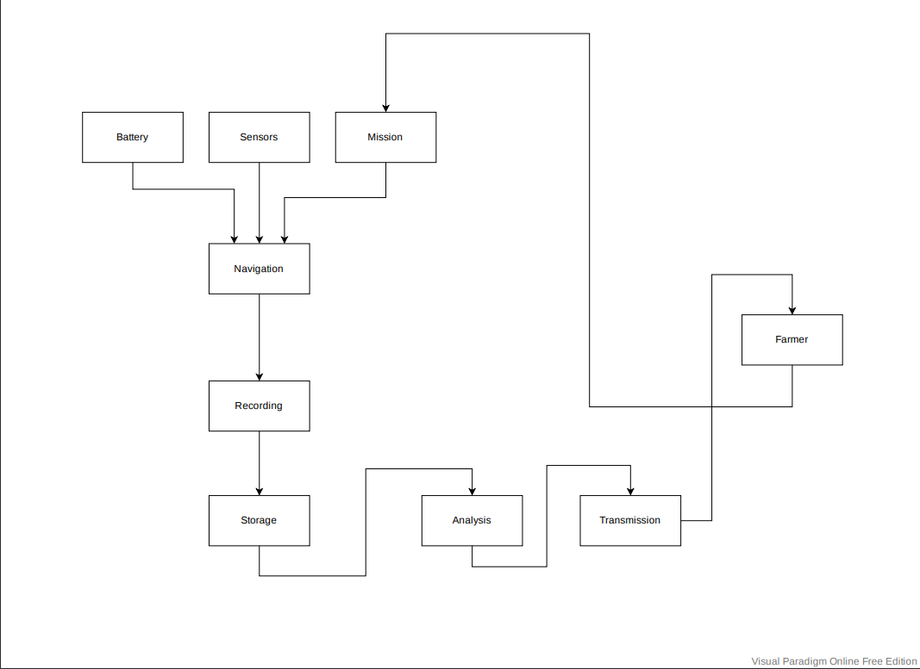

-Activity Diagram

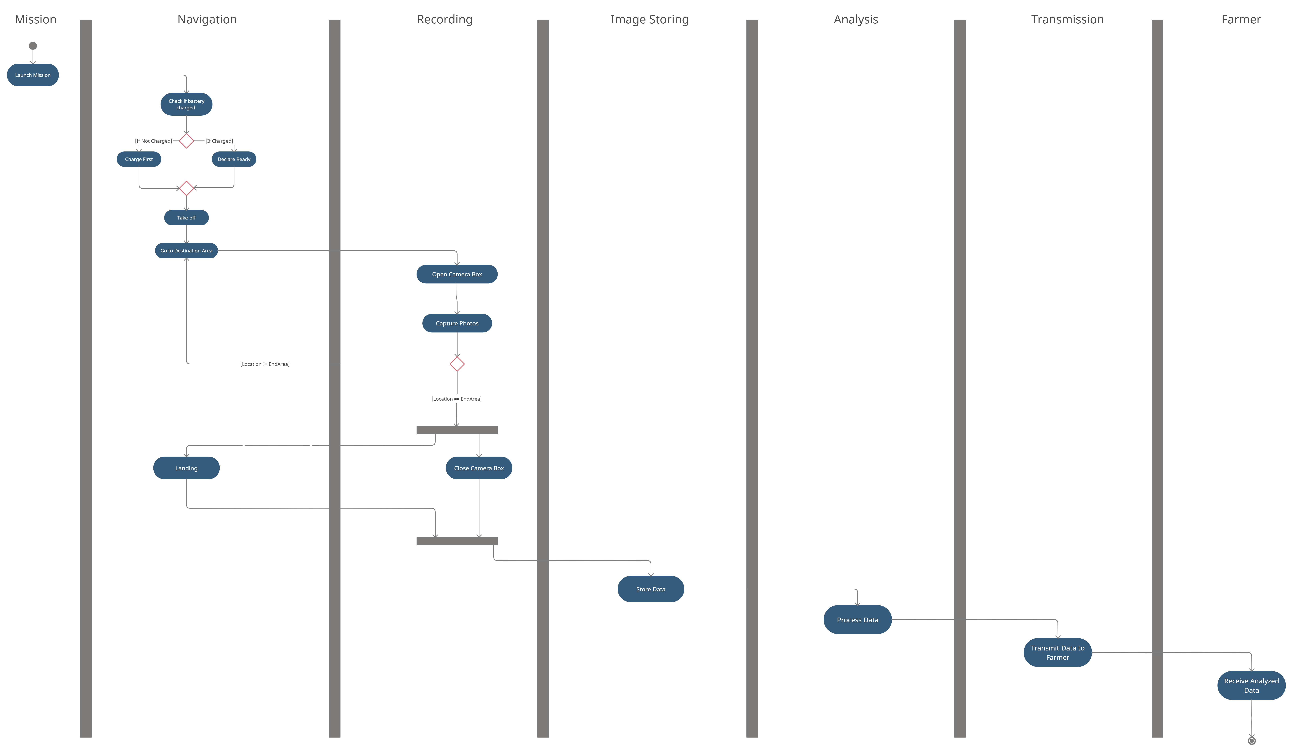

-Use Case Diagram

s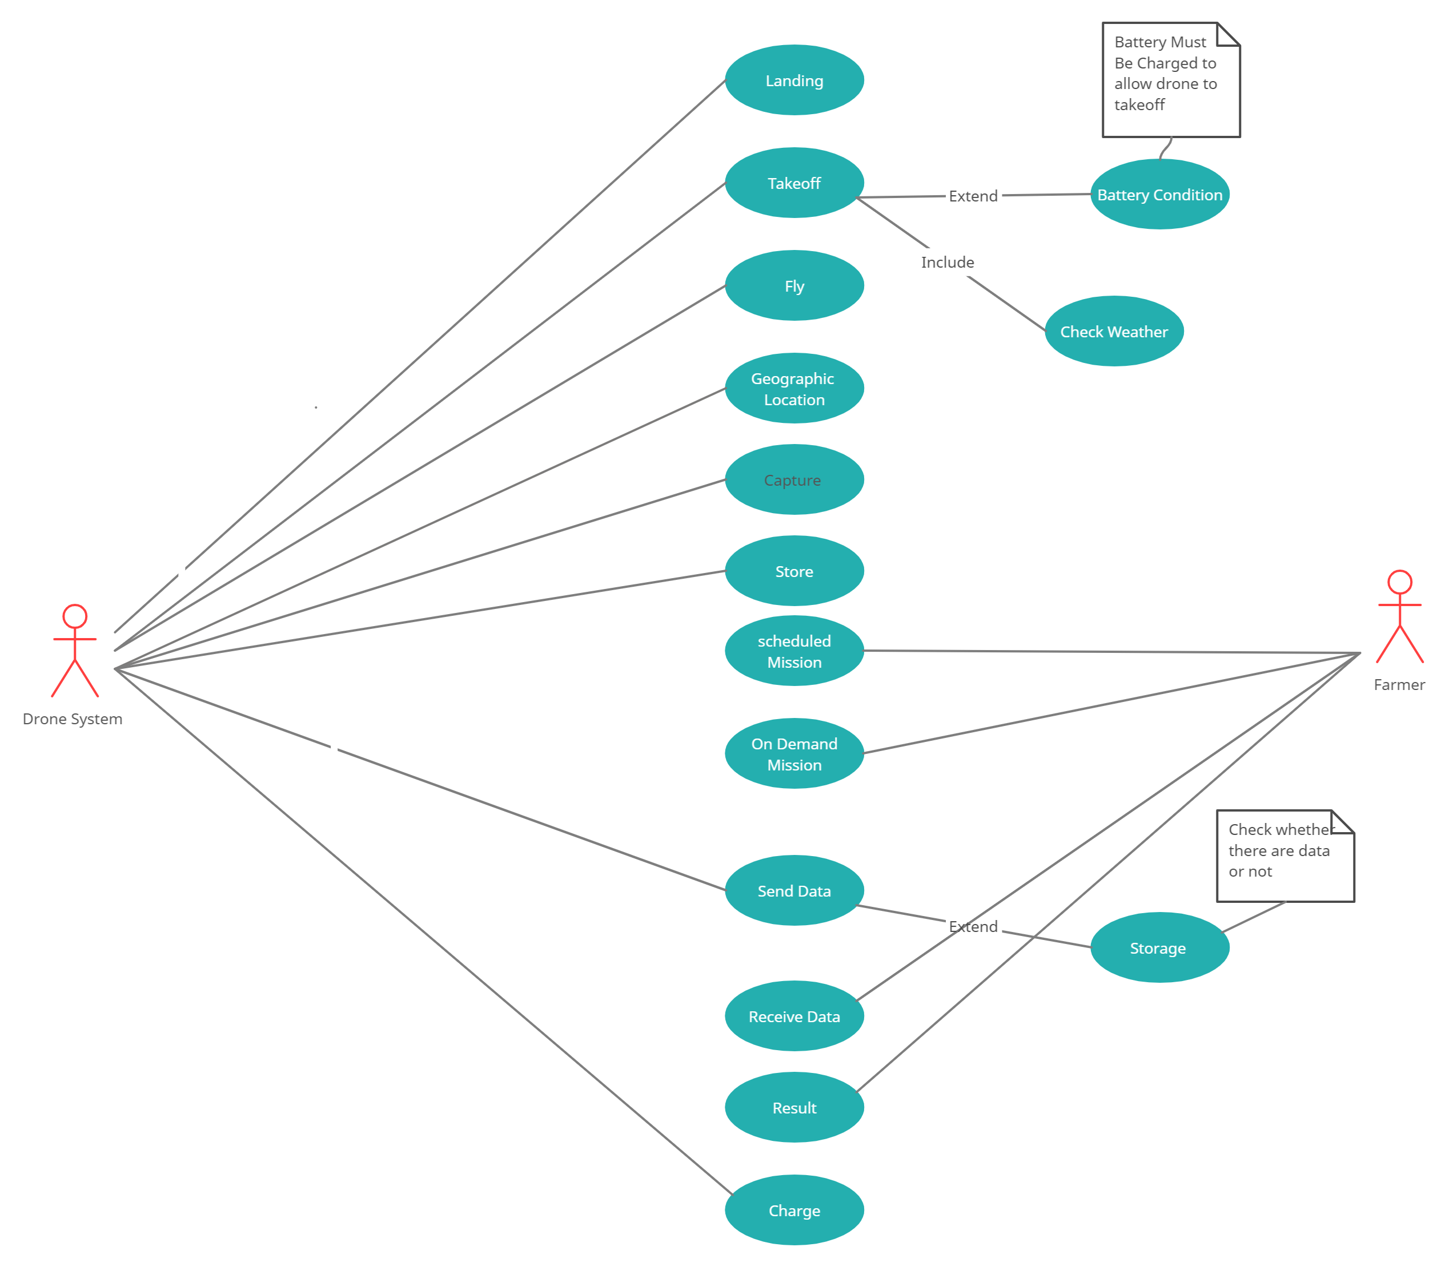

|  |  |  |  |
| --- | --- | --- | --- |
| Identifier and name | | | Take-off |
| Summary | | In the beginning, the drone starts to fly under some conditions | |
| Dependency | | 1-Battery Condition  2-Weather | |
| Actors | | Drone System | |
| Precondition | | The drone must be charged. | |
| Postcondition | | The drone will take-off and will start to fly. | |
| Main success Scenario | 1. **the drone system will check battery condition and if battery is full so it will take off otherwise it won’t.** 2. **The drone must check weather.** | | |
| Extensions | 1.a-Battery is low.  1.a.1- The Drone will start charging.  2.a- the weather is not good.  2.a.1- the drone will not take off. | | |
| Non-Functional | * performance requirement: The drone must take off in 5 seconds. | | |

|  |  |  |  |
| --- | --- | --- | --- |
| Identifier and name | | | Fly |
| Summary | | The Drone is flying after checking many conditions | |
| Dependency | | None | |
| Actors | | Drone System | |
| Precondition | | Take off | |
| Postcondition | | Drone is flying | |
| Main success Scenario | 1. **After taking off, the drone is flying** | | |
| alternative | None | | |
| Non-Functional | availability requirement: The drone must be operational all the time of the mission. | | |

|  |  |  |  |
| --- | --- | --- | --- |
| Identifier and name | | | Capture |
| Summary | Drone captures some images to inspects crop health and gathers crop stress data | | |
| Dependency | Camera and Storage | | |
| Actors | Drone System | | |
| Precondition | The drone must be in the specified location. | | |
| Postcondition | The drone captures some images and store it. | | |
| Main success Scenario | | 1. The drone is in the specified location. 2. It covers a specified area. 3. It captures images for the crops. 4. It stores the images. | |
| alternative | | None | |
| Non-Functional | | 1. performance requirement: the images must be clear with details. | |

هف

|  |  |  |  |
| --- | --- | --- | --- |
| Identifier and name | | | Store |
| Summary | A function which stores the captured images to send it later to the farmer. | | |
| Dependency | None. | | |
| Actors | Drone System | | |
| Precondition | Some images must be captured. | | |
| Postcondition | Captured images will be stored. | | |
| Main success Scenario | | 1. Drone will capture some images. 2. It will store it to send it later. | |
| alternative | | None | |
| Non-Functional | | None | |

|  |  |  |  |
| --- | --- | --- | --- |
| Identifier and name | | | Send Data |
| Summary | The drone sends captured images to the farmer to analyse it. | | |
| Dependency | Whether there are data or not(Storage). | | |
| Actors | Drone System | | |
| Precondition | The drone must capture images for crops | | |
| Postcondition | The drone will send those images of the crops to the farmer | | |
| Main success Scenario | | 1. The drone will send captured images to the farmer | |
| alternative | | There are no data(images) to be send. | |
| Non-Functional | | None | |

|  |  |  |  |
| --- | --- | --- | --- |
| Identifier and name | | | Receive Data |
| Summary | The drone will capture some images and send it to the farmer so we will use this function to receive these data | | |
| Dependency | Storage | | |
| Actors | Farmer | | |
| Precondition | Images will be stored in drone system | | |
| Postcondition | The drone system will send those images to the farmer | | |
| Main success Scenario | | 1. The Drone will store data. 2. It will send these data to the farmer. 3. The farmer will receive these data to inspects crop health and gathers crop stress data. | |
| alternative | | Images are not sent | |
| Non-Functional | | None. | |

|  |  |  |  |
| --- | --- | --- | --- |
| Identifier and name | | | Capture |
| Summary | Drone captures some images to inspects crop health and gathers crop stress data | | |
| Dependency | Camera and Storage | | |
| Actors | Drone System | | |
| Precondition | The drone must be in the specified location. | | |
| Postcondition | The drone captures some images and store it. | | |
| Main success Scenario | | 1. The drone is in the specified location. 2. It covers a specified area. 3. It captures images for the crops. 4. It stores the images. | |
| alternative | | None | |
| Non-Functional | | 1. performance requirement: the images must be clear with details. | |

|  |  |  |  |
| --- | --- | --- | --- |
| Identifier and name | | | Scheduled Mission |
| Summary | The farmer may schedule mission for the drone system. | | |
| Dependency | The farmer | | |
| Actors | Farmer | | |
| Precondition | None | | |
| Postcondition | A scheduled mission will be added to the drone system | | |
| Main success Scenario | | The farmer will schedule a mission. | |
| alternative | | None | |
| Non-Functional | | None | |

|  |  |  |  |
| --- | --- | --- | --- |
| Identifier and name | | | On Demand Mission |
| Summary | The farmer may make a “On Demand Mission” for the drone system | | |
| Dependency | Farmer | | |
| Actors | Farmer | | |
| Precondition | None | | |
| Postcondition | “On Demand Mission” will be made for the drone system | | |
| Main success Scenario | | The farmer will make a “On Demand Mission” for the drone system | |
| alternative | | None | |
| Non-Functional | | None | |

|  |  |  |  |
| --- | --- | --- | --- |
| Identifier and name | | | Scheduled Mission |
| Summary | The farmer may schedule mission for the drone system. | | |
| Dependency | The farmer | | |
| Actors | Farmer | | |
| Precondition | None | | |
| Postcondition | A scheduled mission will be added to the drone system | | |
| Main success Scenario | | The farmer will schedule a mission. | |
| alternative | | None | |
| Non-Functional | | None | |

|  |  |  |  |
| --- | --- | --- | --- |
| Identifier and name | | | Receive Data |
| Summary | The drone will capture some images and send it to the farmer so we will use this function to receive these data | | |
| Dependency | Storage | | |
| Actors | Farmer | | |
| Precondition | Images will be stored in drone system | | |
| Postcondition | The drone system will send those images to the farmer | | |
| Main success Scenario | | 1. The Drone will store data. 2. It will send these data to the farmer. 3. The farmer will receive these data to inspects crop health and gathers crop stress data. | |
| alternative | | Images are not sent | |
| Non-Functional | | None. | |

|  |  |  |  |
| --- | --- | --- | --- |
| Identifier and name | | | Landing |
| Summary | Function to land the drone after finishing its work. | | |
| Dependency | Scheduled mission or On Demand missions. | | |
| Actors | Drone System. | | |
| Precondition | Scanning the area, capturing images and sending them to the farmer. | | |
| Postcondition | Turn off | | |
| Main success Scenario | | 1.fininshing its work.  2.Returns to its box. | |
| alternative | | None | |
| Non-Functional | | Performance requirements: Time Accuracy. | |

|  |  |  |  |
| --- | --- | --- | --- |
| Identifier and name | | | Result |
| Summary | It is the result of the analysis which the farmer will make it. | | |
| Dependency | Drone images and the analysis. | | |
| Actors | Farmer | | |
| Precondition | Analysis. | | |
| Postcondition | The farmer will be able to know the reasons for the stress which decrease crop yields. | | |
| Main success Scenario | | 1. Analysis 2. Result of this analysis. 3. The farmer will make actions. | |
| alternative | | None | |
| Non-Functional | | performance requirement: High Accuracy | |

|  |  |  |  |
| --- | --- | --- | --- |
| Identifier and name | | | On Demand Mission |
| Summary | The farmer may make a “On Demand Mission” for the drone system | | |
| Dependency | Farmer | | |
| Actors | Farmer | | |
| Precondition | None | | |
| Postcondition | “On Demand Mission” will be made for the drone system | | |
| Main success Scenario | | The farmer will make a “On Demand Mission” for the drone system | |
| alternative | | None | |
| Non-Functional | | None | |

|  |  |  |  |
| --- | --- | --- | --- |
| Identifier and name | | | Result |
| Summary | It is the result of the analysis which the farmer will make it. | | |
| Dependency | Drone images and the analysis. | | |
| Actors | Farmer | | |
| Precondition | Analysis. | | |
| Postcondition | The farmer will be able to know the reasons for the stress which decrease crop yields. | | |
| Main success Scenario | | 1. Analysis 2. Result of this analysis. 3. The farmer will make actions. | |
| alternative | | None | |
| Non-Functional | | performance requirement: High Accuracy | |

|  |  |  |  |
| --- | --- | --- | --- |
| Identifier and name | | | Landing |
| Summary | Function to land the drone after finishing its work. | | |
| Dependency | Scheduled mission or On Demand missions. | | |
| Actors | Drone System. | | |
| Precondition | Scanning the area, capturing images and sending them to the farmer. | | |
| Postcondition | Turn off | | |
| Main success Scenario | | 1.fininshing its work.  2.Returns to its box. | |
| alternative | | None | |
| Non-Functional | | Performance requirements: Time Accuracy. | |

-**State Machine Diagram** & **Stimuli/response** Identification

Navigation State chart diagram

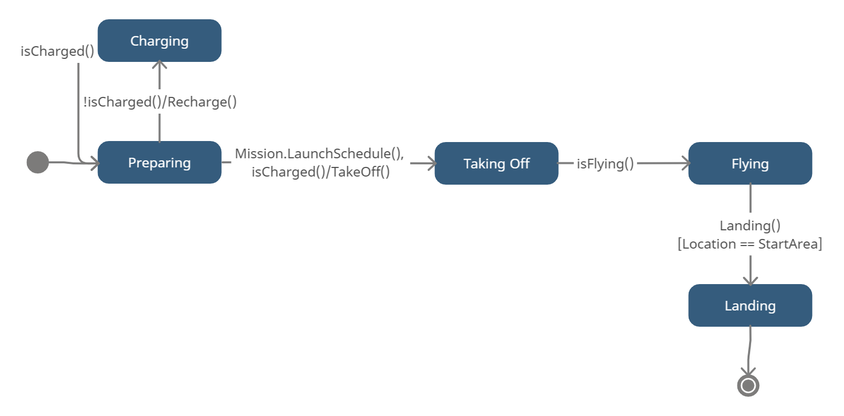

Stimuli: Flying Drone

Response: Charging, Flying , Landing

Transmission State Chart Diagram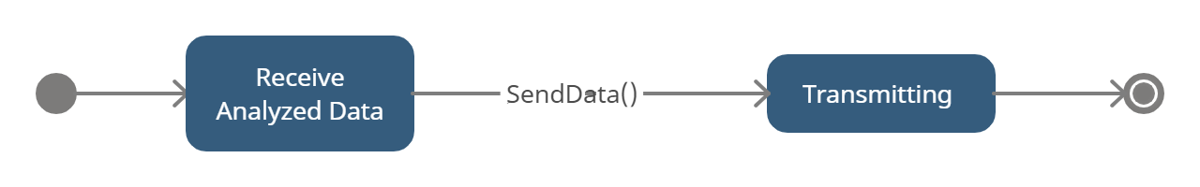

Stimuli: Transfer image and analyzed data

Response: transmit data to farmer

Recording State Chart

Stimuli: Open Camera and recording

Response: Recording and store images

B-Static Analysis

-class Diagram

Class Diagram Version 1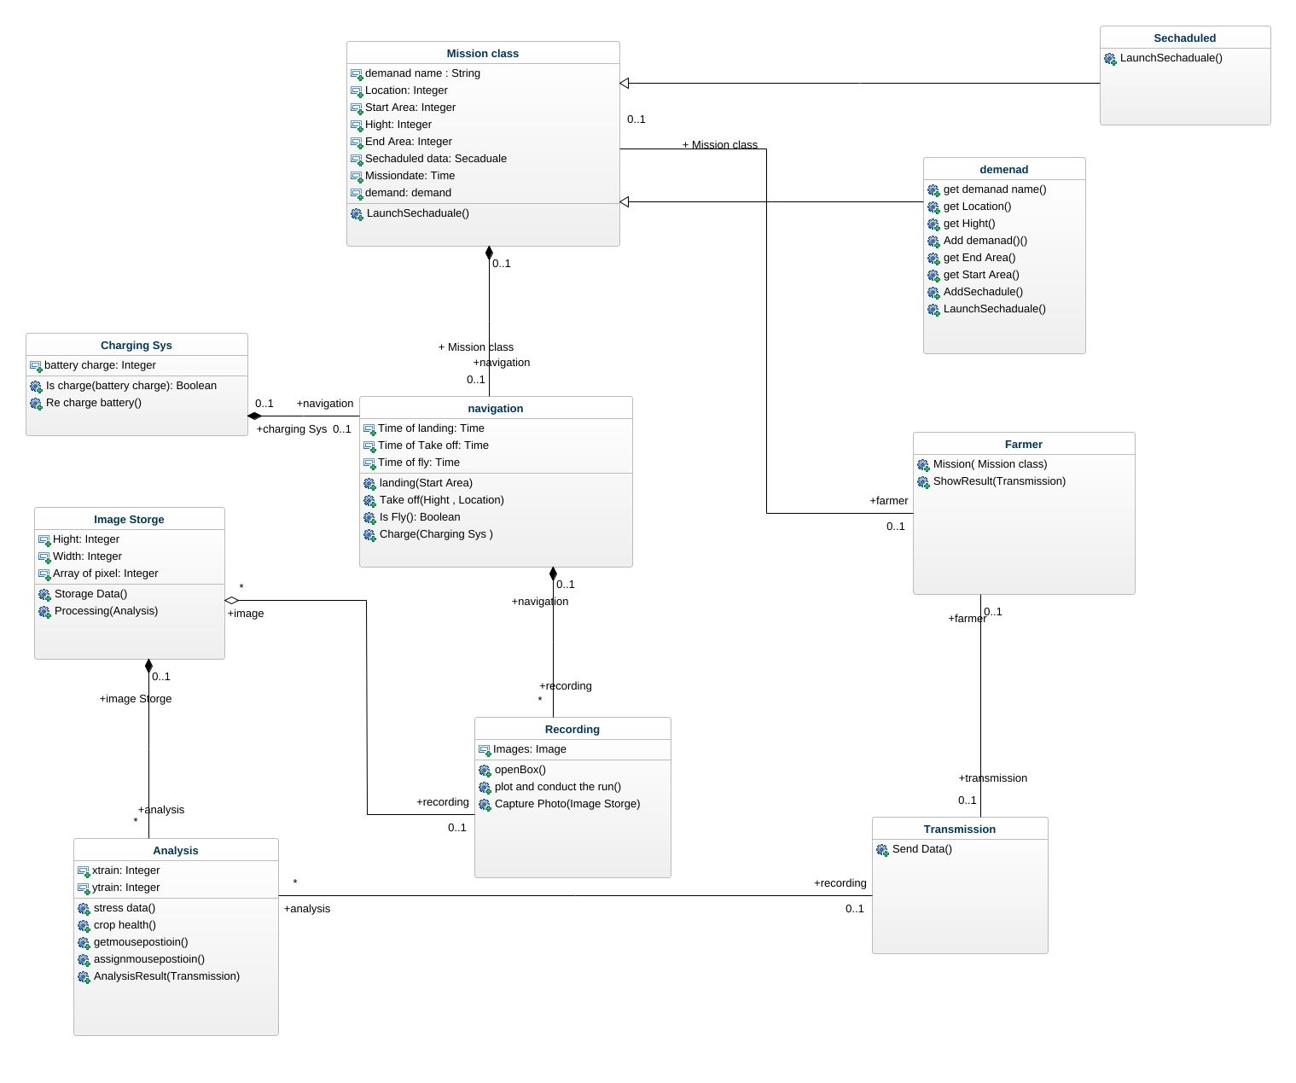

Class Diagram Version 2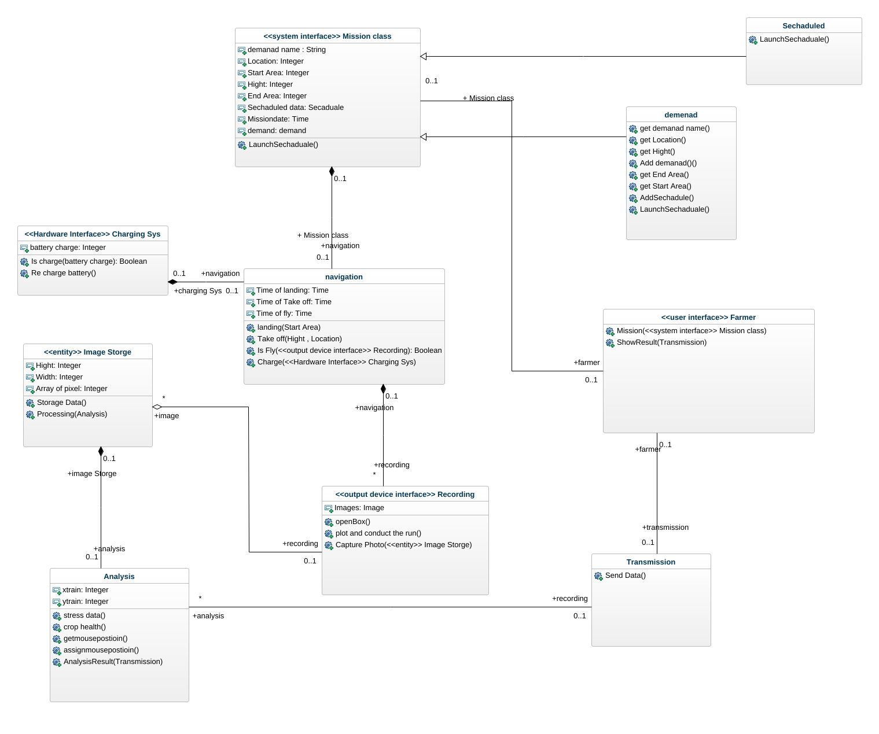

C- Dynamic Analysis

Note: State Chart Diagram is before Class diagram

-Interaction Diagram

